Project Planning Phase
Project Planning Template (Product Backlog, Sprint Planning, Stories, Story points)
Date | 06/09/2026
Team ID | Servicenow
Project Name | Automated Network Request Management
Maximum Marks | 5 Marks

Product Backlog, Sprint Schedule, and Estimation (4 Marks)
Use the below template to create product backlog and sprint schedule.
Sprint | Functional Requirement (Epic) | User Story Number | User Story / Task | Story Points | Priority | Team Members
Sprint-1 | Network Request Submission | USN-1 | As a requester, I can submit a network request via the Service Catalog by entering connection type, address, and payment details. | 3 | High | Asritha
Sprint-1 |  | USN-2 | As a requester, I only see the “Existing ID” field when Type of Connection = Existing. | 2 | Medium | Asritha
Sprint-1 | Automated Record Creation | USN-3 | As the system, I automatically create a Database Tables record from the submitted catalog variables. | 3 | High | Asritha
Sprint-1 | Notifications | USN-4 | As a requester, I receive an email confirming my request was submitted. | 1 | High | Asritha
Sprint-2 | Approval Routing | USN-5 | As an approver, I receive the request in my approval queue via ServiceNow's native Approval engine. | 5 | High | Asritha
Sprint-2 |  | USN-6 | As the system, I branch on the approval outcome (Approved / Rejected) using Flow Logic. | 3 | High | Asritha
Sprint-2 | Notifications | USN-7 | As a requester, I receive an email once my request is approved or rejected. | 2 | High | Asritha
Sprint-2 | Access Control | USN-8 | As an admin, I can restrict access to request records through role-based ACLs (u_database_tables_user). | 3 | Medium | Asritha

Project Tracker, Velocity & Burndown Chart: (4 Marks)
Sprint | Total Story Points | Duration | Sprint Start Date (Planned) | Sprint End Date (Planned) | Story Points Completed (as on Planned End Date) | Sprint Release Date (Actual)
Sprint-1 | 9 | 6 Days | 03 Aug 2026 | 08 Aug 2026 | 9 | 08 Aug 2026
Sprint-2 | 13 | 6 Days | 10 Aug 2026 | 15 Aug 2026 | 13 | 15 Aug 2026

Velocity:
Imagine we have a 10-day sprint duration, and the velocity of the team is 20 (points per sprint). Let's calculate the team's average velocity (AV) per iteration unit (story points per day):
AV = sprint duration / velocity = 20/10 = 2
Automated Network Request Management — Velocity:
Applying the same formula to this project: total story points completed across both sprints = 22, over 2 sprints of 6 days each.
Velocity = Total Story Points Completed / Number of Sprints = 22 / 2 = 11.0 Story Points per Sprint.

Burndown Chart:
A burn down chart is a graphical representation of work left to do versus time. It is often used in agile software development methodologies such as Scrum. However, burn down charts can be applied to any project containing measurable progress over time.
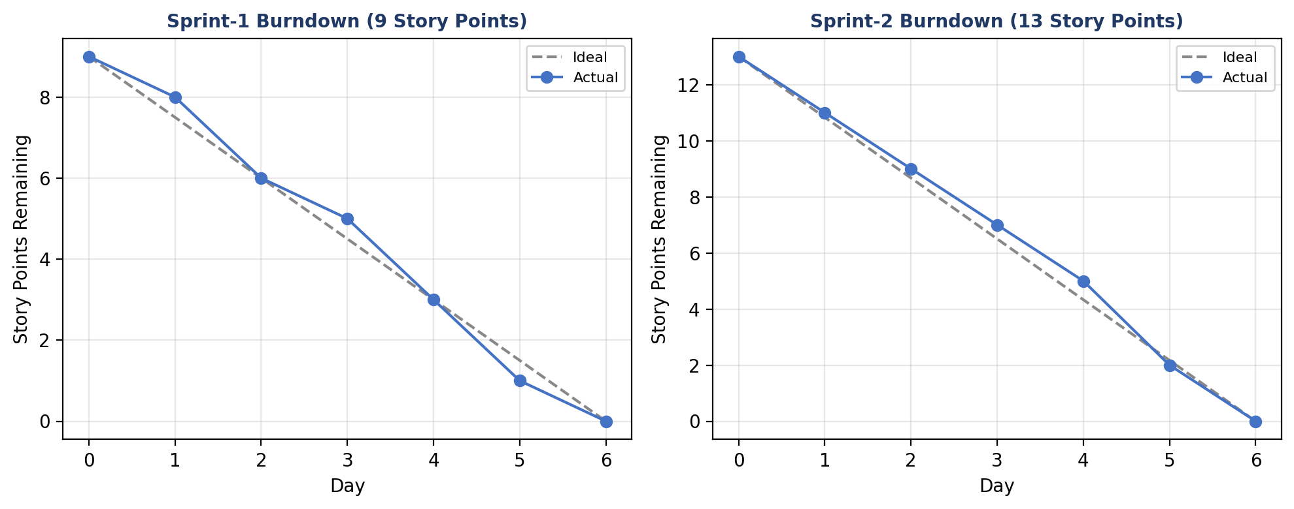
Both sprints for Automated Network Request Management tracked close to the ideal burndown line and were completed within their planned 6-day duration, with all committed story points delivered on schedule.

References:
https://www.visual-paradigm.com/scrum/scrum-burndown-chart/
https://www.atlassian.com/agile/tutorials/burndown-charts

https://www.atlassian.com/agile/project-management
https://www.atlassian.com/agile/tutorials/how-to-do-scrum-with-jira-software
https://www.atlassian.com/agile/tutorials/epics
https://www.atlassian.com/agile/tutorials/sprints
https://www.atlassian.com/agile/project-management/estimation
https://www.atlassian.com/agile/tutorials/burndown-charts

